./

Learning Report – Applied SDLC

Course Code: <CODE>



|  |  |  |  |  |  |
| --- | --- | --- | --- | --- | --- |
| **Ver. Rel. No.** | **Release Date** | **Prepared. By** | **Reviewed By** | **Approved By** | **Remarks/Revision Details** |
|  |  |  |  |  |  |
|  |  |  |  |  |  |
|  |  |  |  |  |  |
|  |  |  |  |  |  |
|  |  |  |  |  |  |

**Document History**

# 

​

Contents

Definition of smartwatch 4

Ageing 4

Cost Gradation 4

SWOT Analysis 5

Requirements 5

High level requirements 5

Low level requirements 5

Design 6

State Transition Diagram 6

Use Case Diagram for smartwatch 7

Complex State machine diagram 9

Internal Structure diagram 10

Test Plan 10

Focus areas for testing smartwatches 10

Feasible options for testing smartwatches 11

Core smartwatch testing scenarios 11

Test plans in given template 13

AGILE METHODOLOGY 14

THEME 14

EPIC 14

USER STORIES 14

Schematic of Agile methodology 15

References 15

LEARNING REPORT - 2

Name: Hemanth Kumar Venkatasri Chebiyam

PS No.: 99002592

Product - SMARTWATCH

Definition of smartwatch*:* A smartwatch is a form of wearable technology that can track major human vitals and link up with mobile phone. It can also collect data and suggest what changes in lifestyle is needed.

Ageing*:* Wearable technology is a relatively unexplored field and smartwatches were one of the first products to spearhead this new industry.

We have normal wrist watches, luxury watches, sportswear watches, fitness trackers, and now, smartwatches.

Smartwatches initially started off as basic devices that you could sync up with your phone and check messages or just any notifications in general.

After a few years, the rise of fitbits and similar products started. Most of these smartwatches started giving information like step-count and heart rate, etc.

Fast-forward to the current day scenario, we have extremely advanced smartwatches which are almost as powerful as certain basic smartphones, possessing some high-level specs.

Cost Gradation*:* Smartwatches can be classified into 3 categories based on performance and features:

* Basic Performance: Such smartwatches serve the basic purpose of having GPS and connecting to phone and displaying basic notifications. May/May not include touch screen.

Such devices would be classified as low cost devices

* Intermediate Performance: These devices will have more functionality and would provide a few more interesting features to the customer such as real-time heart rate, calorie count, etc. It would have a touch screen and would give access to most stuff on your mobile phone.

Such devices could be expensive based on the features they provide.

* High Performance: High-end devices with superior performance and premium features.

Such devices would be much more costly.

|  |  |
| --- | --- |
| Performance | Cost |
| Basic Performance | Low cost |
| Intermediate Performance | Can be expensive based on certain features |
| High Performance | Very expensive |

SWOT Analysis*:*

Strengths:

* Can access lots of data
* Can give many different varieties of information like step-count, heart-rate, etc.
* Gives personalized suggestions regarding workouts and fitness
* Easy User-Interface
* Robust touch-screen

Weakness:

* Over-reliant on certain sensors
* May not be extremely accurate
* Tends to be more of estimation than actual values
* Having many features can make it costly

Opportunities:

* Can link up to phone and have more functions
* Can start measuring new data

Threats:

* Can be susceptible to hacks
* Inaccurate data

Requirements*:*

High level requirements:

* It comes under wearable technology, so it should be comfortable to wear over prolonged periods of time and in different circumstances.
* Multiple sensors which are accurate.
* An efficient embedded system which makes it a "smart" watch.
* Easy and smooth communication of data wirelessly.
* Simple UI for customer usage.

Low level requirements:

* Should be able to give accurate step count.
* Long last battery life.
* Should have heart rate sensor and should also have GPS.
* Attractive and durable screen (touch screen).
* Compatible to phone OS.
* Fast charging.

High level requirements:

|  |  |
| --- | --- |
| ID | Description |
| 001 | Simple design of wrist band |
| 002 | Easy user-interface |
| 003 | Data transfer is smooth |

Low level requirements:

|  |  |
| --- | --- |
| ID | Description |
| 001 | Battery should last for atleast 20 hrs (based on usage) |
| 002 | Ability to display basic content available on the mobile that it is linked to |
| 003 | GPS can track walking patterns and determine approximate daily routine |

Design*:*

## State Transition Diagram

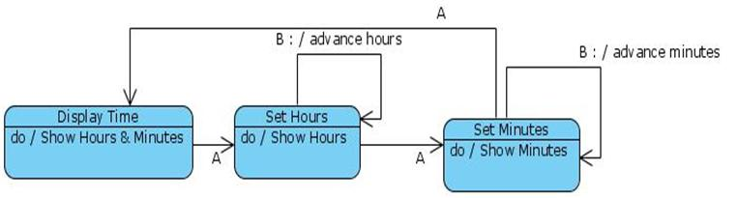

## Use Case Diagram for smartwatch

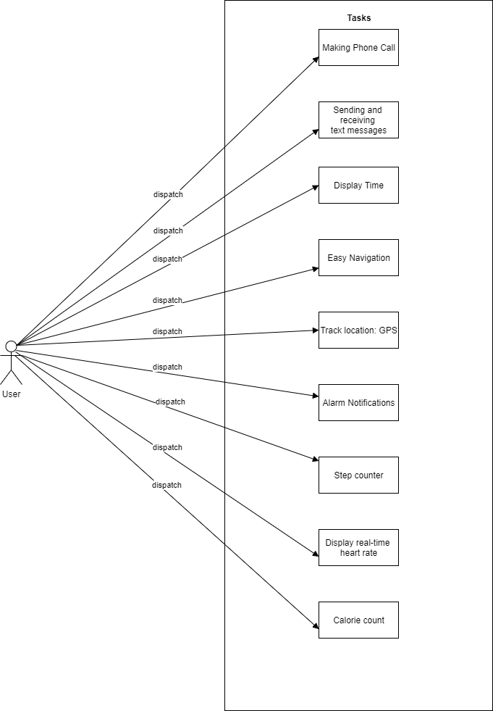

## Complex State machine diagram

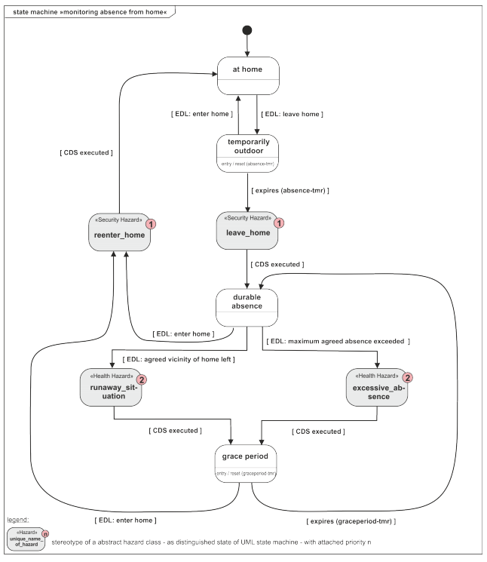

## Internal Structure diagram

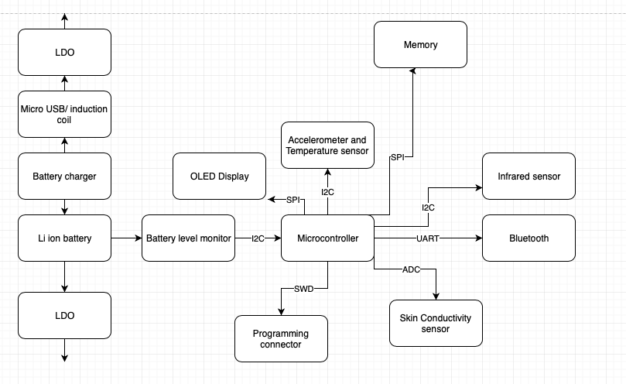

Test Plan*:*

Focus areas for testing smartwatches*:*

* Sensors: Accuracy of sensors directly impact the user experience and the demand of a device in the market. So, test the smartwatch sensors in all possible physical and scientific conditions.
* Notifications: Notifications on a smartwatch should be quick, accurate, multilingual, and enable the user to take appropriate action. To achieve these, test the notifications with different lengths, sizes, and types of data and validate the visibility of notifications on these quality parameters.
* Battery Life: Smartwatches’ battery life must last longer. Since wearable devices constantly consume battery via sensors, app notifications, and connectivity with the cell phone, you should check the battery consumption frequency separately for every sensor and app.

Feasible options for testing smartwatches*:*

* Functional Testing
* Usability Testing
* Compatibility Testing
* Performance Testing
* Security Testing
* Compliance Testing
* Localization Testing

Core smartwatch testing scenarios*:*

* Connectivity and disconnectivity testing between smartwatch and smartphone
* Testing push notifications from smartphone
* Testing data synchronization on smartwatches and smartphones
* Smartwatch sensors testing while performing physical activities
* Testing of different connectivity types like bluetooth, NFC, and Wi-Fi
* Connection range testing by moving far from smartphone
* Smartwatch touch sensitivity testing with dry, sweaty, and tattooed skin
* Battery consumption checks

Let’s consider the scenario of testing the connectivity.

The proper functioning of a smart device is strongly dependent on how well it is connected with the mobile phone. If connection with the phone is lost, the device becomes as useful as ‘e-waste’, so testing the connection is vital. There are several tests that can be run to check connection, such as the following:

* From different directions of location of the phone
* From different ranges
* In and out of range
* For low power status
* After the phone is re-started
* After the device is taken off charging point

|  |  |  |
| --- | --- | --- |
| **#** | **Possible Test Case** | **Expected Result** |
| 1 | Remove the pairing between the smartphone/ tablet and the smartwatch. | If the smartwatch app offers some “offline” functionality where a smartphone/ tablet is not needed this functions must work. |
| 2 | Remove the app from the smartphone/ tablet but not from the smartwatch. | Depending on the mobile operating system the watch should show the data that the app can show. Otherwise the app must show a user friendly text informing the user about the missing app on the smartphone/ tablet. |
| 3 | If your app requires a login, be logged out on the smartphone/ tablet. | The smartwatch must be in a logout state, too. |
| 4 | If your app requires a login, be logged in on the smartphone/ tablet. | The user must be logged in on the smartwatch, too. |
| 5 | Activate flight mode on smartphone/ tablet but not on the smartwatch. | The connection between the smartphone/ tablet and smartwatch will be lost. However, the smartwatch app must still work with the data that is available on the device. Depending on the app it may show an error that the connection has been lost. |
| 6 | Check the different data states the app can have e.g. no data, massive data. | The smartwatch app must work with no and massive app data. |
| 7 | Send all the supported push notification types to the smartphone/ tablet and have a smartwatch paired. | All supported push types must be visible on the smartwatch as well. The information must be readable. If there are call to actions in place, check that all actions are working. |
| 8 | Check that UX and design guidelines are met. | All design and UX elements must pass the platform guidelines. |
| 9 | Check the battery state during the testing activities. (Smartwatches usually have 1-2 days of battery life, except Pebble watches. Check also the battery life of your phone.) | The battery consumption must be appropriate to its usage. Note down the battery consumption every 10 minutes and compare it with other version. The same applies for the smartphone/ tablet. |
| 10 | Check the different connectivity types e.g. Bluetooth, Wi-Fi, NFC, Check also that the fallback connection option is used. | All used connectivity types must work as expected. A fallback option maybe Wi-Fi. |
| 11 | Test the different gestures. | All supported and used gestures must work. |

Test plans in given template**:**

|  |  |  |  |  |  |
| --- | --- | --- | --- | --- | --- |
| ID | Description | Pre-condition | Expected input | Expected output | Actual output |
| 001 | Bluetooth pairing to smartphone | Bluetooth to be on in both devices | Bluetooth option selected | Successful pairing | **If paired**-bluetooth symbol shown.  **If not**-no symbol |
| 002 | Heart-rate sensor testing | Smartwatch should be charged | Watch worn properly, sensor has access to wrist | Correct value of heart-rate of user is displayed | **If sensor is working properly**-heart rate displayed.  **If not**-error message displayed |
| 003 | GPS Tracking | Device should be charged and should have tracking capability | Location services should be enabled | Current location displayed at any given point of time | **If working**- location displayed.  **If not**-ask user to check connection |
| 004 | View messages and emails from smartphone | Phone should be paired to watch | User to navigate to email/messages section in smartwatch | Most recent emails/messages are successfully displayed | **If displayed**-user can browse.  **If not**- error message displayed |
| 005 | Touch-screen testing | Smartwatch has touch-screen feature | User is asked to press screen for certain time | Touch is sensed and notified to user | **If working**- user can use touch screen.  **If not**- error is notified to user |

AGILE METHODOLOGY**:**

THEME:

A smartwatch (wearable technology) that can track major human vitals and link up with mobile phone. It can also collect data and suggest what changes in lifestyle is needed.

EPIC:

Collection of user data and displaying specifics to the customer

USER STORIES:

* Step-counter: When using this smartwatch, I would want an accurate count of how many steps I take while I wear the device and I would also like to know how much distance I have covered.
* Heart-rate: When using this smartwatch, I would want to know my heart-rate at any point of time. I would like to get a clear difference between my active and resting heart-rate.
* Calorie count: By evaluating steps and heart-rate, I would like this smartwatch to tell me how many calories I have lost during a certain time-frame and accordingly suggest certain fitness activities based on my preferences.

# Schematic of Agile methodology

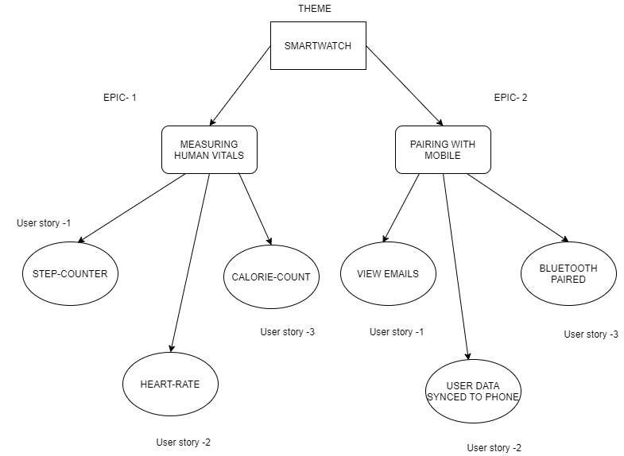

References:

* <https://adventuresinqa.com/2016/03/14/smartwatch-app-testing-ideas/>
* <https://blog.testlodge.com/smart-watch-testing/>
* <https://blog.qasource.com/automation-testing-of-smart-watch-autocast-summer-2019>
* <https://www.atlassian.com/agile/project-management/epics>
* <https://vskumar.blog/2017/10/20/how-the-project-sdlc-model-conversion-can-be-done-from-traditional-v-model-to-agile/>